**Rest APIs : Consuming Rest API via Rest Client**

*Posted On September 24, 2019*

In this post, we will get to see the REST API in action. To do this we will need a public consumable API which are many there on web. We can find Reqres.in to solve our purpose.

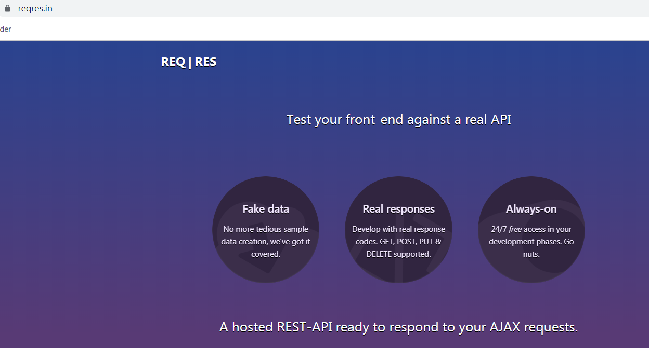

We will make a basic GET and then a POST request.Here we see a list of different GET request and also corresponding Response of each. Like for first List User which is a GET request the response code is 200.

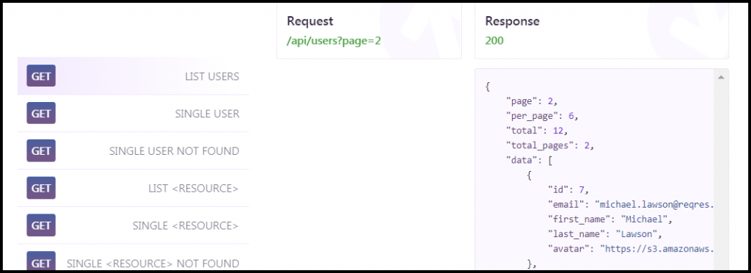

For POST with ‘Register Unsuccessful’ response in with code 404.

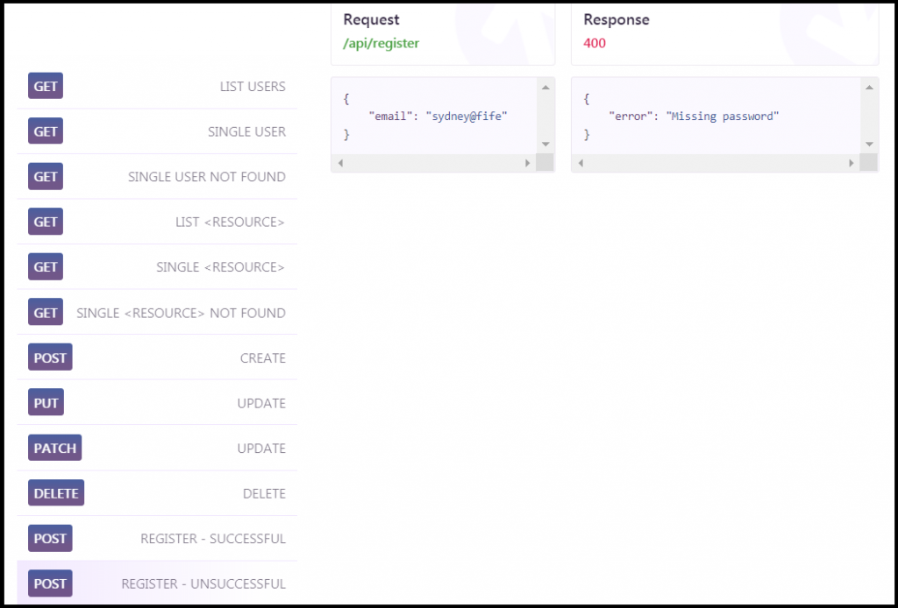

We will send a request like regular request client. Reqres is a restful api that uses HTTP protocol for requests. We can thus use any client that uses HTTP protocol to send the request and our web browser is such client. The response we get is:-

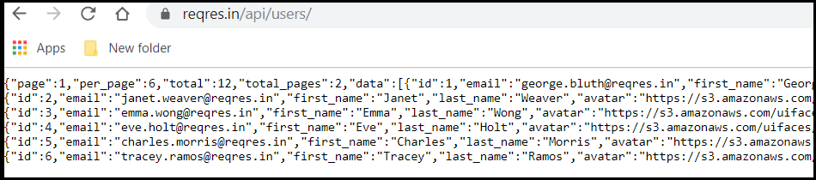

The data is formatted as a text and thus you don’t know what to do with this information and so it is hard to read. This make the response from REST API unreadable.

We need a REST client assigned for this purpose. There are few clients like Postman or there is also a rest client from Visual Studio Market place called as ‘Rest Client’.

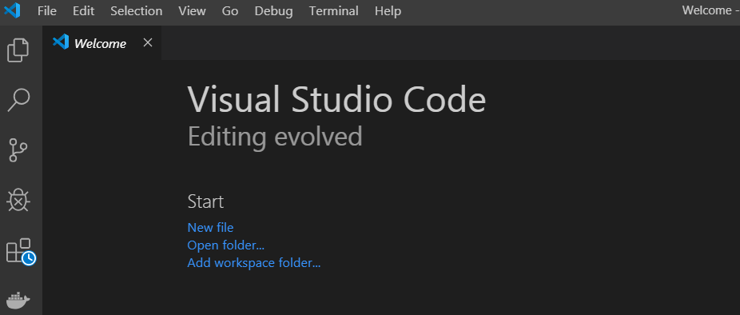

Install the REST client by Opening Visual Studio code and searching for REST Client in extension.

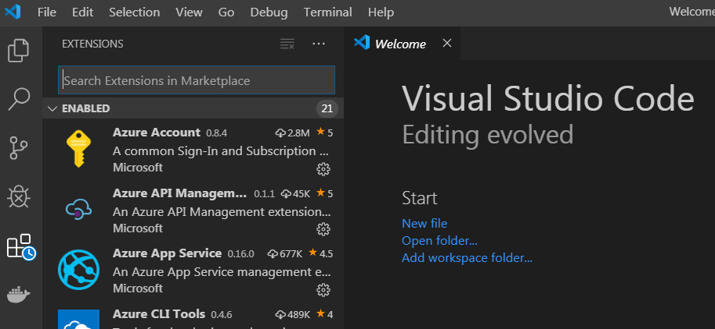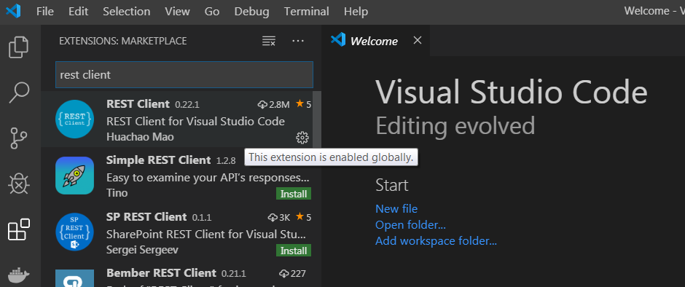

Create a folder in Local, Open that folder through VSCode, Create a new File called as rest.http underneath it.

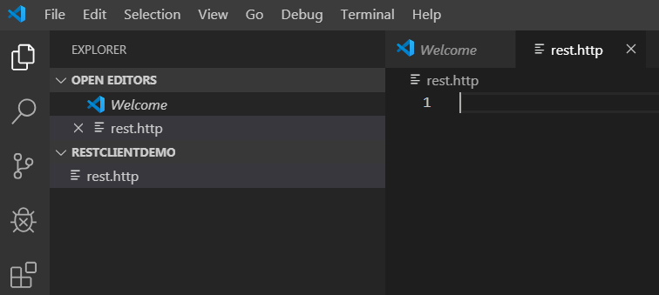

Pressing keys Ctr+ ALT+ R, will open a new window which is a Response Window. This response we got is very different to what we received in Browser. This is because this response contains full REST Response header with metadata information about the response and also format data in human readable form, so it makes easier to understand what is going on in the response.

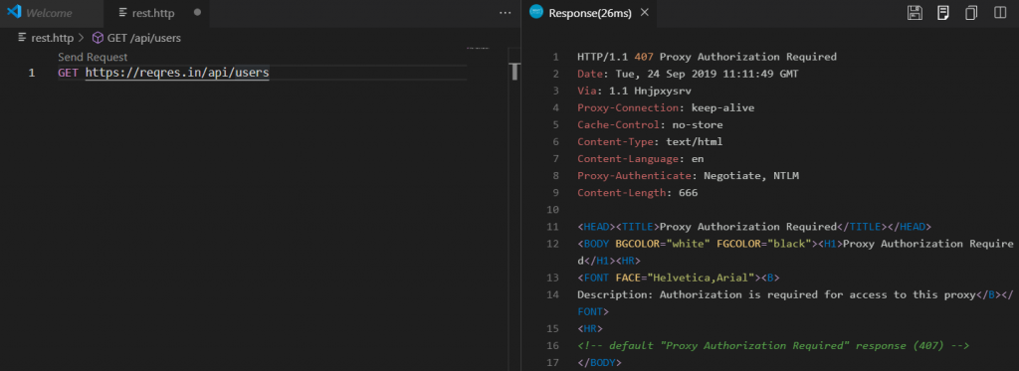

Thus, we can see that we have fully structured data with a nesting and it is a JSON Response with a bunch of properties and values.